Task 3

Kali and Metasploitable IP (ifconfig)

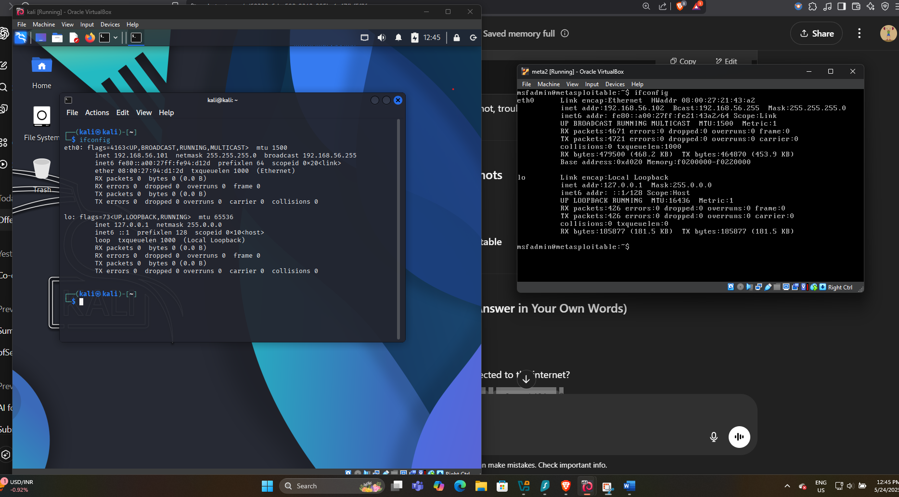

Ping test result of both

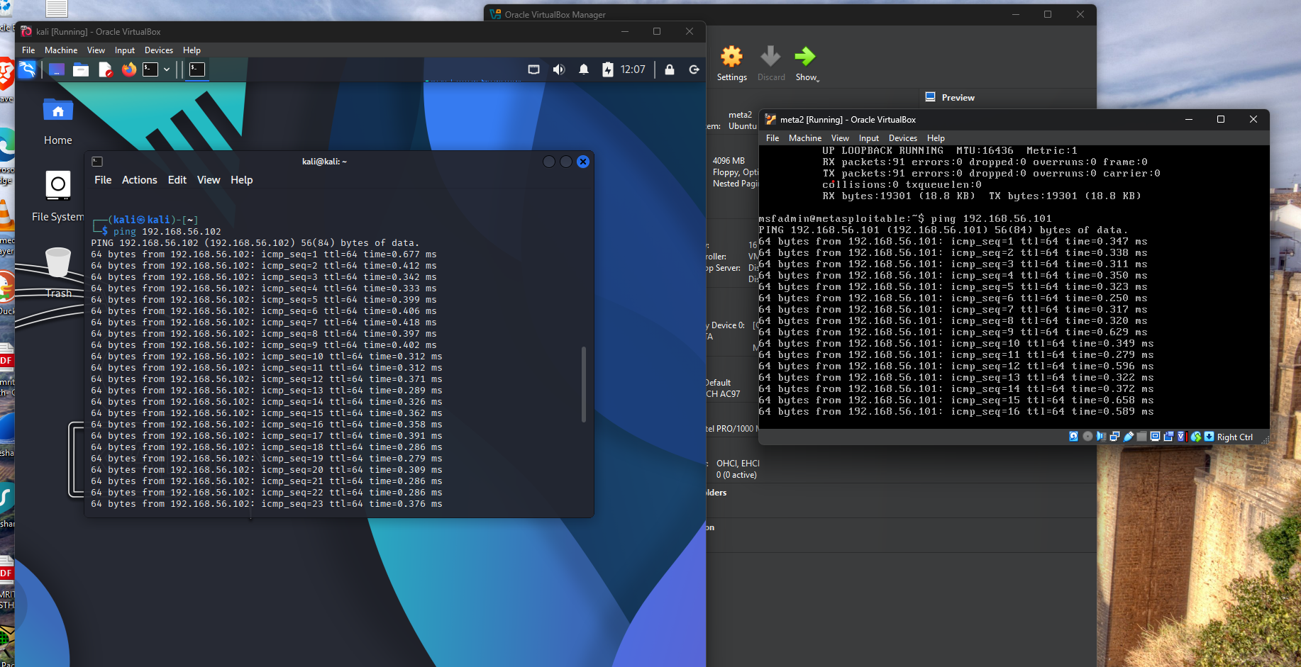

Task 4

1. What is Metasploitable used for?

Ans: It is a virtual machine designed for security training, testing security tools, and practicing common penetration testing techniques.

1. What does “host-only network” mean?

Ans: it is a type of network configuration where the vm can communicate only with the host system and other VMs in the same network, it is isolated from the physical network and cannot access internet or other device on the local network.

1. Why shouldn’t Metasploitable be connected to the internet?

Ans: it shouldn’t be connected to the network, because it is a venerable version of Linux. Poses significant risk, including the possibility of being attacked by the hacker.

1. What do these mean: payload, exploit, vulnerability?

Ans: Vulnerability: it is a weakness in the system that can be exploited by an attacker.

Exploit: a piece of code written to take advantage of a specific venerability in the system.

Payload: is a code that is executed after the system is successfully exploited.